#include <stdio.h>
#include <stdlib.h>

int global = 100;
static int s = 50;

int main()
{
int stack = 10;
int *heap = (int *)malloc(sizeof(int));

printf("Code Segment : %p\n", (void *)main);
printf("Global Segment : %p\n", (void *)&global);
printf("Static Segment : %p\n", (void *)&s);
printf("Heap Segment : %p\n", (void *)heap);
printf("Stack Segment : %p\n", (void *)&stack);

free(heap);

return 0;
}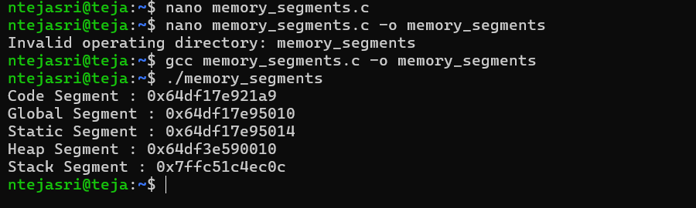

#include <stdio.h>
#include <stdlib.h>

int main()
{
int *a, *b;

a = (int *)malloc(5 * sizeof(int));

b = (int *)calloc(5, sizeof(int));

a = (int *)realloc(a, 10 * sizeof(int));

free(a);
free(b);

return 0;
}

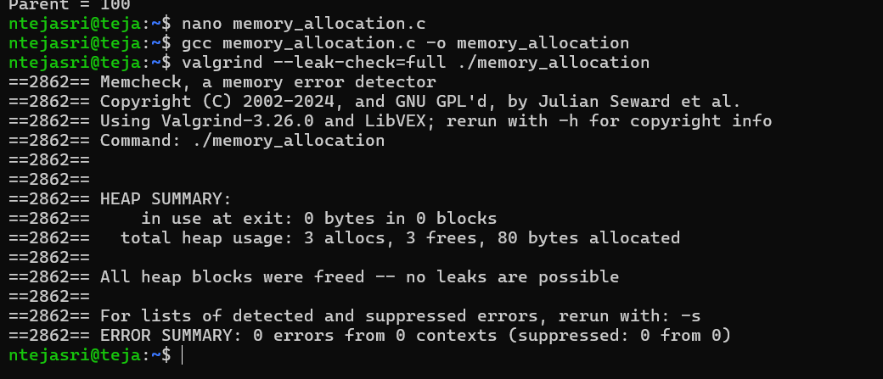
#include <stdio.h>
#include <unistd.h>

int main()
{
int x = 100;

if (fork() == 0)
{
printf("Child Before = %d\n", x);

x = 500;

printf("Child After = %d\n", x);
}
else
{
sleep(2);

printf("Parent = %d\n", x);
}

return 0;
}